

CMC Intake and Process Overview

2/11/2020

10th Magnitude, LLC
20 North Wacker Drive #530
Chicago, IL 60606

Notice of Confidentiality © 2018 10th Magnitude, LLC All rights reserved

THIS DOCUMENT IS 10TH MAGNITUDE PROPRIETARY AND CONFIDENTIAL INFORMATION AND IS SUBJECT TO THE TERMS OF THE 10TH MAGNITUDE NON-DISCLOSURE AGREEMENT. NEITHER THIS DOCUMENT NOR ITS CONTENTS MAY BE REVEALED OR DISCLOSED TO UNAUTHORIZED PERSONS OR SENT OUTSIDE THE AFOREMENTIONED COMPANY WITHOUT PRIOR PERMISSION FROM 10TH MAGNITUDE.
Table of Contents
Introduction 3
CMC Migration Process 4
Migration Group Planning and Execution 5
Migration Prerequisites 6
CMC Ingestion Overview 7
Submit an Automated Service Request 8
Meetings and Communication 9
Documentation 9

Introduction
This document Is Intended to describe the process In which the 10M Internal business should request work from the Cloud Migration Center and how the CMC executes migrations. The CMC Is Intended to be an internal service center with a pool of resources ready to perform and deliver work based on templated requests.
In this document we will outline the service workflow at high level, give an overview of how work Is planned and executed, show how to submit a CMC service request, and outline cadence and documentation standards.

CMC Migration Process

Since the CMC Is Intended to be a service center, all work should be request driven and require specific input. Normally CMC resources will not be directly staffed on projects, but rather will performing work that is planned and requested from a Project Lead/Architect or Business Analyst. The goal of this approach Is to allow CMC resources to focus on concrete work and leave front-end client communication and planning to the project team. This reduces the cost, number of billable hours, and creates an efficient means to deliver repeatable work while adding value.

Migration Process Overview

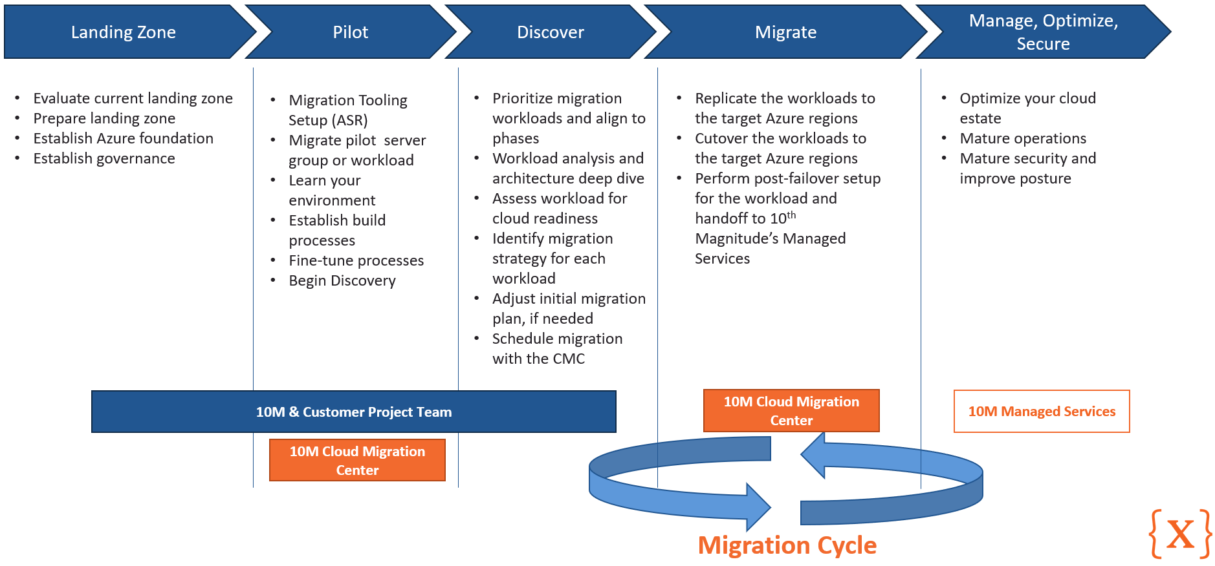

Migration Group Planning and Execution
Migration group planning Is completed by the project team. It Is the project team's responsibility to work with the customer to perform discovery, plan migrations, and handle customer facing cadence and communication. Migration execution Is completed by the CMC based on Input provided by the project team. The CMC works on 1-week sprints to better track resource capacity. A weekly sync meeting will be established for planning and status updates from the CMC to the project team.
The goal Is to establish an overlapping cycle of migration group discovery and group migrations between the project team and the CMC of Discovery -> Migration -> Handoff/Transition to MS -> Repeat. Ideally a two week overlapping discovery/migration cycle should be established so that the CMC Is able to perform one migration group per week for the customer.

An Example Migration Execution Cycle

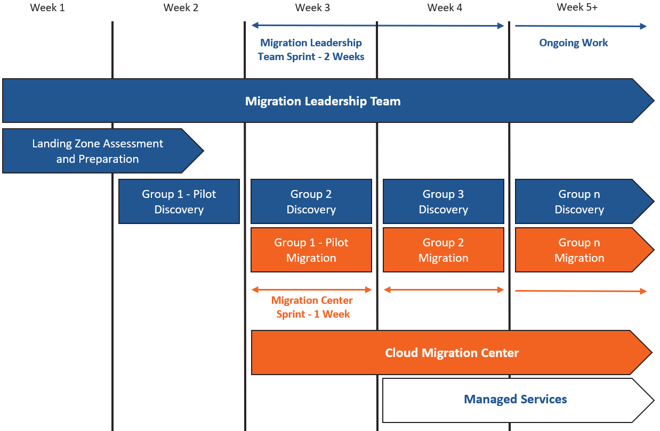

Migration Prerequisites
Before the migration phase of the project can begin and the CMC can be utilized, the following information should be available, or the following items completed:
- A migration timeline has been completed - accurate to roughly a month out.
- The project team has verified the customer has been onboarded into the CMC project.
- Migration tooling is fully set up and in a healthy state. Including other migration prerequisites such as pre-installing the Azure VM Agent if necessary.
- Resource build procedure/process/requirements have been established and added to the project documents.
- Available bandwidth to dedicate to replication has been identified and any bandwidth constraints have been planned and/or necessary bandwidth caps can be configured.
- Base migration strategy has been established for each workload group. In some situations, a different tool or strategy could be used to accommodate some workloads.

CMC Intake Overview
- As discovery is completed for each workload or migration group, a Workload Migration Worksheet must be completed from the output of the Workload Discovery sheets and sessions with the customer. The Migration Workload Worksheet Includes all Information necessary for the CMC to start work and used as the blueprint to migrate the group.
- The project lead or business analyst uploads the sheet and requests service. Before a service request Is created:
  - A timeline for the migration group should be established and noted in the worksheet. When replication can start, a window scheduled when failover should occur, etc.
  - Any required Change Control requests should be started and scheduled to be approved before the window.
  - Time should be scheduled in advance for any parties that need to be Involved - for example: App team testing after failover during the cutover window.
  - The Workload Worksheet should be fully completed and uploaded to the project documents.
- The CMC acknowledges the request and creates a backlog for the migration group. As the team works through the backlog, status Is updated and reported back to the project team via weekly meetings and reports.

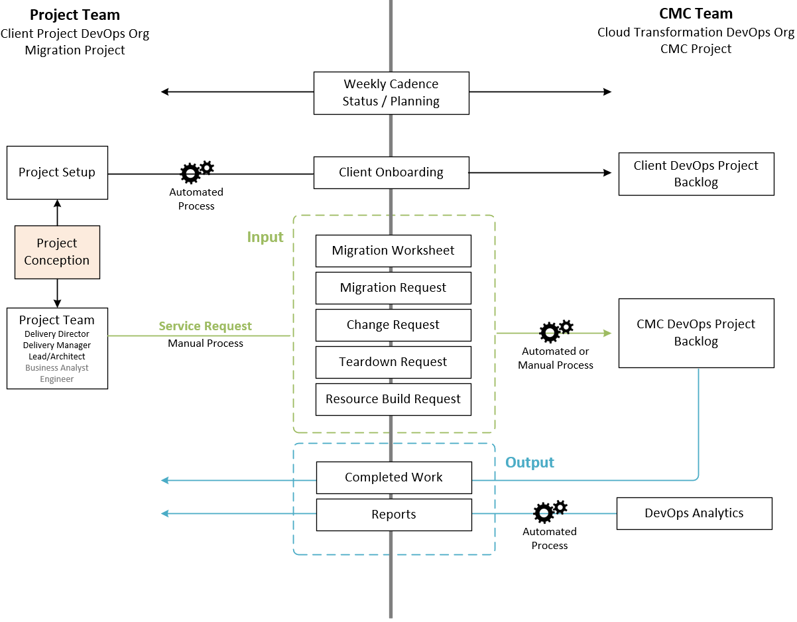

Submit an Automated Service Request
In addition to requests via usual communication channels, basic CMC Service Requests can be submitted via the DCT Portal page on SharePoint:

- Click the Submit CMC Request quick link

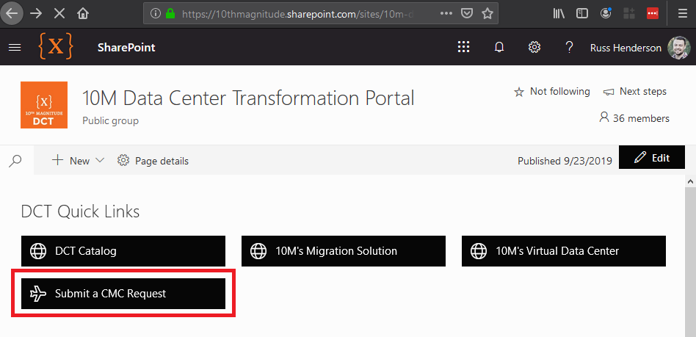

- Verify prequisites are met and submit the appropriate request by filling out the form with the required Information.

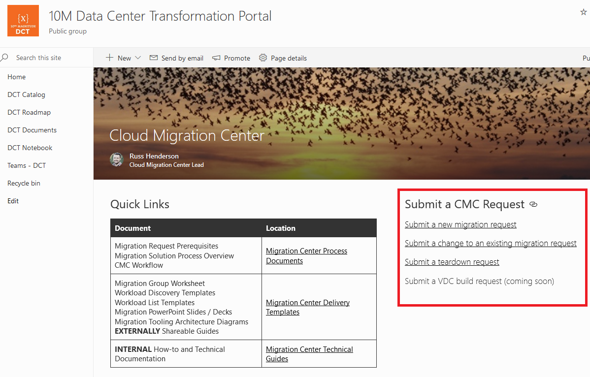

- An automated email response Is generated If the request Is received successfully with a DevOps work Item number.
- The CMC will reach out with any questions If needed. The request Is planned against capacity and acknowledged or timeline modification is requested.

Meetings and Communication
Since the Cloud Migration Center Is not directly staffed on projects, the team does not join typical project standups, sprint planning, and status calls. In order to keep work In sync with the project team, the CMC follows the following cadence.

Type | Cadence | Parties Involved | Purpose
Project Team Sync | Weekly | CMC Lead  Project Team | Dicuss and plan upcoming work for the week.  Call out and plan for remediation of blockers.
Discovery Sessions | Weekly (or as planned) | Project Lead and/or  Business Analyst | Discuss application architecture with the client, develop migration strategy and scheduling
Cutover Session | Weekly (or as planned) | Project Lead  CMC Lead  Assigned CMC Engineer(s) | Orchestrate and execute server failover activities as planned.
Customer Communication | As Needed | Project Team

Documentation
Cloud Migration Center and Migration documentation, guides, worksheets, and templates can be found on SharePoint. The table below outlines common CMC documentation and where it can be found.

Document | Location
Migration Request Prerequisites  Migration Solution Process Overview  CMC Workflow | Migration Center Process Documents
Migration Group Worksheet  Workload Discovery Templates  Workload List Templates  Migration PowerPoint Slides / Decks  Migration Tooling Architecture Diagrams  EXTERNALLY Shareable Guides | Migration Center Delivery Templates
INTERNAL How-to and Technical Documentation | Migration Center Technical Guides

